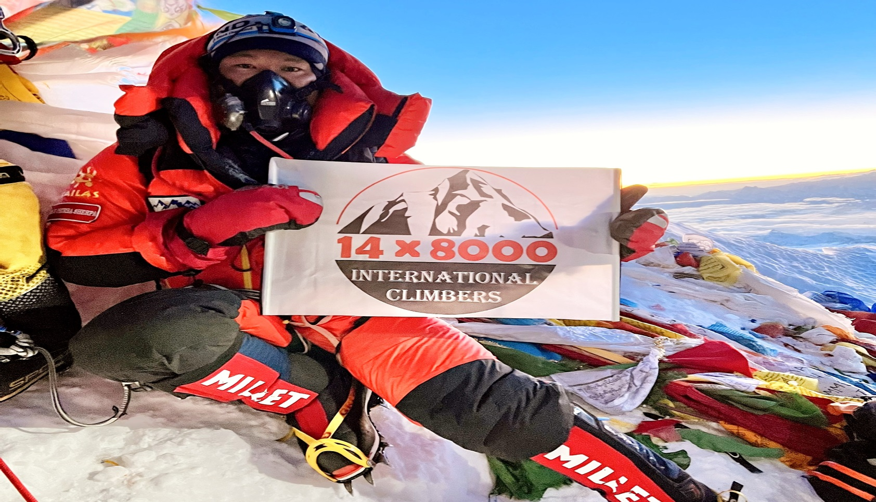

EVEREST EXPEDITION-(SOUTH) NEPAL - 2023 [8848.86M.]

Mt. Everest Expedition is a lifetime mountaineering experience that allows you to stand on the highest point in the world.

TRIP FACTS:

PEAK NAME SERVICE COUNTRY

**MT. EVEREST** (SAGARMATHA) **FULL BOARD** (1:1 SHERPA) **NEPAL**

DURATION ROUTE GRADE

**60 DAYS S-COL; SE-RIDGE HARD DIFFICULT**

RANGE BEST SEASON MAX ELEVATION

**MAHALANGUR SPRING 8848.86 M**

WALKING PER DAY NATURE GROUP SIZE

**5-7 HOURS HOTEL + LODGE 2-15 PAX**

D

ARRIVAL DEPARTURE TO LUKLA TRIP ENDS

**07 April 2023 09 April 2023 05 – 09 June 2023**

Required Experience:

Experience in mountaineering (6000 m. /7000 m. /8000 m.) is recommended and required to sign up this expedition.

Consider Climbing Lobuche PEAK (6119 M.) for Extra Acclimatization

For people with a sufficient time frame, an excursion to nearby Lobuche Peak, 6119m, is a great way to ensure you are well acclimatized before you start the Mt. Everest Expedition.

Overview:

Ask an adventurer about their dream, and they will answer you with a word; **EVEREST.** Who would not want to reach the top of the world? Who would not want to touch the sky? It’s the trip of the lifetime, the Everest Expedition. **Mount Everest,** also known as The Sagarmatha in Nepali is the tallest peak on earth with an altitude of 8848.86m. The southern face lies in Nepal whereas the northern face is in Tibet. In 1715, China surveyed the mountain for the first time while they were mapping Chinese territory and depicted it as Mount Qomolangma. British Indian government 1856 again measured Mount Everest during their Great Trigonometry Survey. Back then, it was named Peak XV and said to be 8840m tall.

Peak XV was renamed after Sir George Everest as Mount Everest, the name given in his honor, who was a lead surveyor in 1856. Sir George was a Welsh Surveyor; he was the surveyor-general of India for thirteen years from 1830. Everest has fascinated mountaineers all around the globe since the 1920s when Tibet opened climbing in the early 1920s. In 1922 British Expedition team led by Charles Bruce tried to scale the summit of Mount Everest for the first time. It was Edward Norton in his second attempt along with the British Expedition team that set the height of 8572m. The mountaineers George Mallory and Andrew Irvine disappeared on the third attempt. Mallory's body was found in 1999. There were several attempts made to Everest before the successful attempt made by **Edmund Hillary and Tenzing Norgay** on 29 May 1953 via the South route. It is now reported that around 1000 ascent attempts are made every year.

We will take the southern route to the summit. This trip suits those who have previous experiences of a few 7000m peaks or even more. The real trek apparently starts from the Base Camp and to reach the base camp takes you around 7 days on foot. We will move on to **Camp I (6,065m)** where we will see the **Khumbu glacier**.  Khumbu Glacier is around 450m on a gradual slope to **Camp II (6,750m)** and around 610m to **Camp III (7,300m)**. Camp III is located at the head of Lhotse. From this point onwards, you will need oxygen cylinders. You will reach **Camp IV (7,910m)** after just crossing 8000m elevations. This point is also known as the Death Zone.

Mount Everest Expedition is undoubtedly a lifetime opportunity. Nevertheless, these expeditions encounter many hindrances such as high altitude, severe weather conditions, and avalanches. One must be well trained before actually trying it. You need to get your body ready for the**8848.86m**-foot climb to Everest's summit. Depending on your current level of fitness, you need to train for several months before you start your ascent. A climber must build his/her cardiovascular strength along with muscular strength; oxygen level drops by 60-70 percent from sea level. Also, make sure you can carry big backpacks to the top as you will be carrying a cylinder of oxygen and large bag packs along with you. One must acclimatize with weather conditions and be prepared for rock falls, and avalanches. Learning rescue techniques would be an added advantage.

Our Airbus, Heli Everest will all the time be supporting our team by supplying fresh - fruits, vegetables, meats, and other food items almost every day, and it's also always ready for your safety at your needs.

**" We await to serve you our service and share our experience with you "**

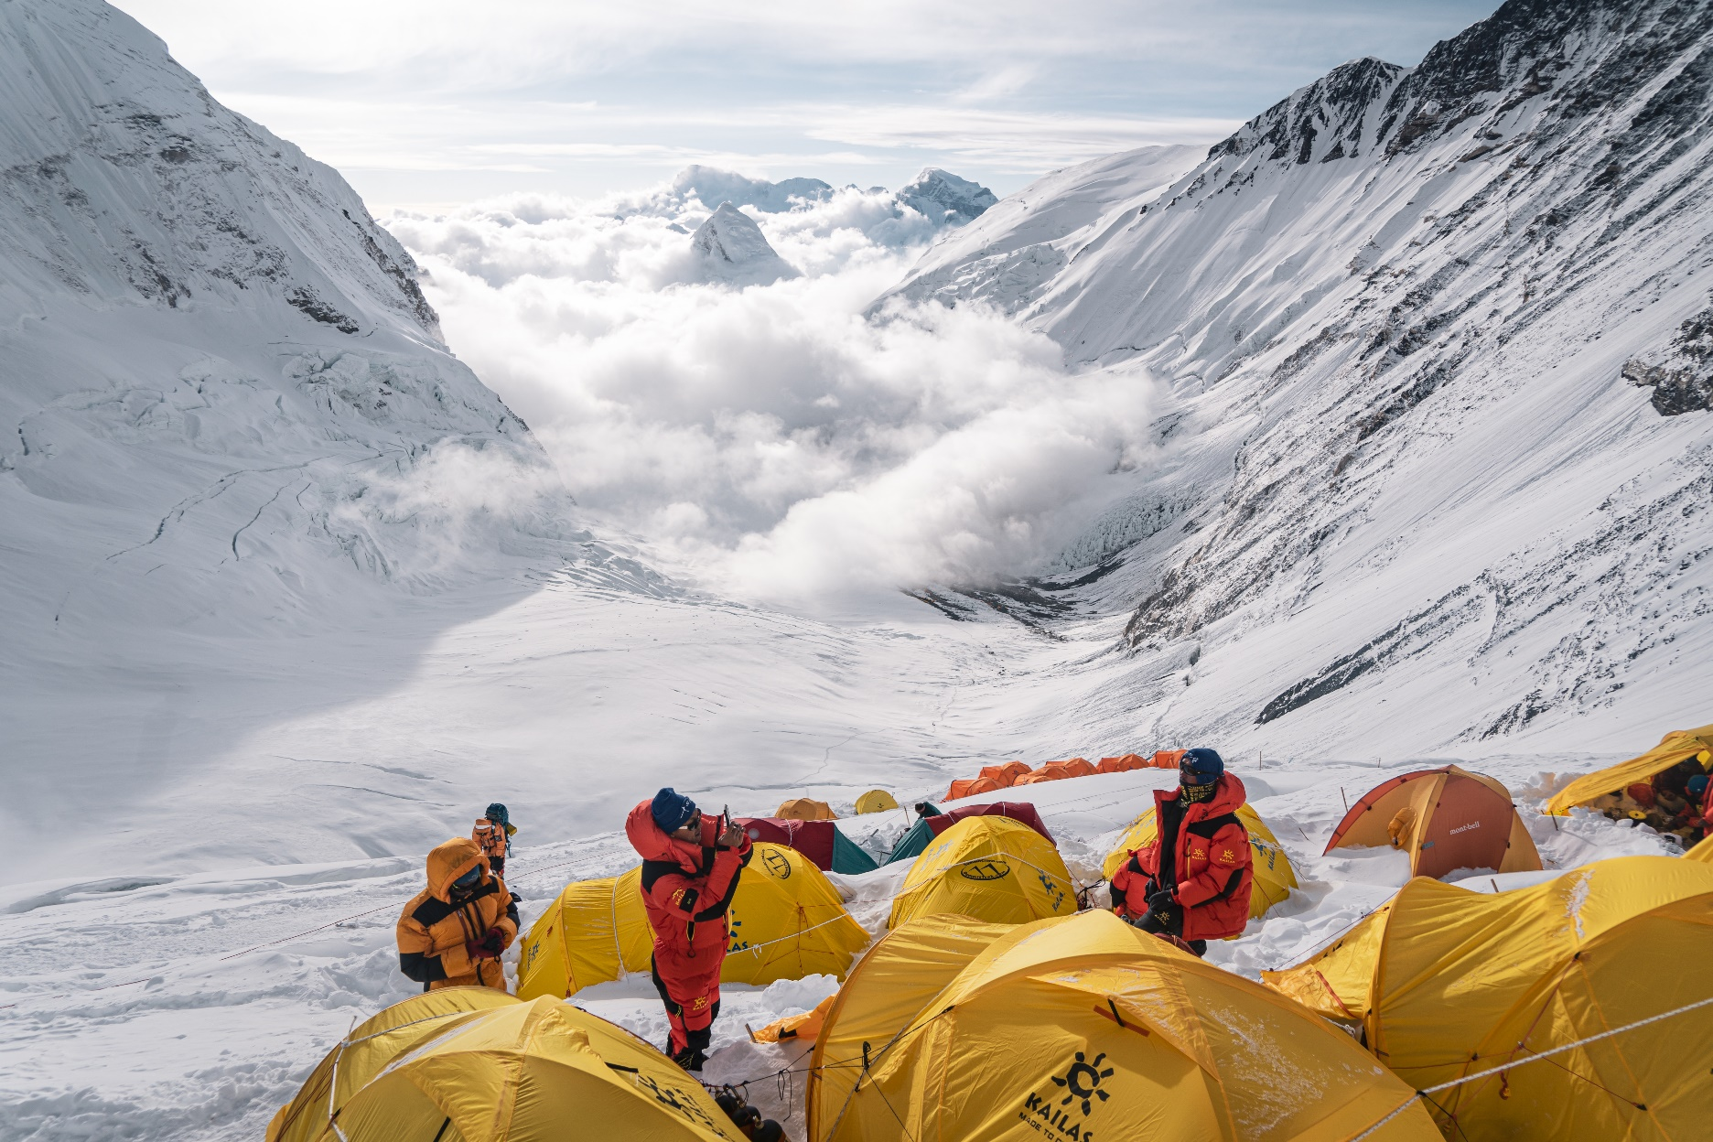

EVEREST CAMP-III 7300M.

ITINERARY:

|  |  |  |  |  |
| --- | --- | --- | --- | --- |
| Days | Itinerary | DATE | MEALS | board |
| 1 | Arrival to Kathmandu & Transfer to the Hotel (1,400m) |  | - | Hotel |
| 2 | Rest in Kathmandu, expedition briefing and Preparation |  | B/D | Hotel |
| 3 | Fly from Kathmandu – Lukla and trek to Phakding (2,800m) |  | B/L/D | Lodge |
| 4 | Trek from Phakding to Namche Bazzar (3,440m) |  | B/L/D | Lodge |
| 5 | Acclimatization at Namche Bazaar (rest day) |  | B/L/D | Lodge |
| 6 | Trek from Namche Bazzar to Dibuche (3,870m) |  | B/L/D | Lodge |
| 7 | Trek from Dibuche (3,870m) to Dingboche (4,243m) |  | B/L/D | Lodge |
| 8 | Trek from Dingboche to Lobuche (4,930m) |  | B/L/D | Lodge |
| 9 | Trek from Lobuche to Everest Base Camp (5,364m) |  | B/L/D | Tent |
| 10-39 | Rotation: [Basecamp – Rotation (Camp I, Camp II and Camp III) – Basecamp] |  | Full Board  High Camp | |
| 40-53 | Climbing Period [Base Camp – Everest Summit (8,848.86m) – Base Camp] |  | Full Board  High Camp | |
| 54 | Cleaning Up Base Camp |  | B/L/D | Tent |
| 55 | Trek from Base Camp to Pheriche (4,371m) |  | B/L/D | Lodge |
| 56 | Trek from Pheriche to Namche Bazaar |  | B/L/D | Lodge |
| 57 | Trek from Namche Bazaar to Lukla |  | B/L/D | Lodge |
| 58 | Fly from Lukla to Kathmandu & transfer to Hotel |  | B | Hotel |
| 59 | Leisure day in Kathmandu City |  | B | Hotel |
| 60 | Transfer to International Airport for final departure |  | Breakfast | |

B= Breakfast, L= Lunch and D= Dinner.

COST INCLUDES:

1. **Arrival and Departure**: Airport - Hotel transfers – Airport (Pick Up and Drop), by private vehicle.
2. **Hotel Accommodation in Kathmandu:**4 nights hotel in Kathmandu (4-star category) - single room on bed and breakfast plan.
3. **Welcome Dinner:**One Welcome Dinner in a tourist standard restaurant in Kathmandu with Office’s Staff.
4. **Cargo Clearance:**Assistance for cargo clearance in Nepal’s Customs, clearance cost is subject to a charge.
5. **Permit:**Expedition Royalty and permit fee of Nepal Government to climb Mt. Everest, Sagarmatha National Park, and Pasang Lhamu Rural Municipality entry permit and fee.
6. **Icefall Fee: Khumbu Icefall** climbing **charge** to (SPCC) Sagarmatha Pollution Control Committee.
7. **Liaison Officer:**1 Government Liaison officer with full equipment, salary, and accommodation.
8. **Garbage Management:**Stool Shipment Transfer & Garbage Deposit fees.
9. **Insurance:**Medical & Emergency rescue Insurance for all involved Nepalese staff during the trek and expedition.
10. **Map:**Trekking and climbing map.
11. **Duffle Bag:** One 14mount8000 Duffle Bag.
12. **Member transportation:**  
    -(Domestic Flight) Fly from Kathmandu – Lukla and while returning Lukla - Kathmandu, as per itinerary.
13. **Expedition Stuffs Transportation: All**necessary expedition equipment transportation for all Members and Staff from Kathmandu to Lukla (by air cargo) and to Base camp (by Porters / Yak) – While returning: Base camp to Lukla (by porters / Yak) and Lukla to Kathmandu (by air cargo). Based on the condition expedition staff may transfer by land (KTM-Phaplu) or Heli (KTM-Lukla).
14. **Member Luggage:**Up to 70 Kg per member for personal baggage during the trek to be carried by porters or Yaks.
15. **Food and Lodging:** 3 meals a day (breakfast, lunch, and dinner; including tea and coffee) along with accessible accommodation at Hotel/Lodge during the trek and at the Basecamp. Hygienic and fresh green vegetables, fresh meat, fruits, soft drinks, and juice will be served on a regular basis during the entire expedition using helicopter flights. Well-managed base camp set up for members & Staff.
16. **Porter:**Porters per member up to the basecamp and from the basecamp (both way).
17. **Base Camp Staff:**Experienced and well-trained Base Camp Cook & kitchen Helpers as required.
18. **Staff Salary and allowance:**All Nepalese staff & porter’s daily wages, salary, equipment, food & clothing.
19. **Base Camp Tent:**Each member will have an individual box tent in Base Camp.
20. **Base Camp Equipment:**Single Tent, foam mattresses and pillow per member, 1 Dinning Tent, 1 Kitchen Tent, 1 Communication tent, 1 Toilet & 1 Shower Tent, 1 Staffs Tent, 1 Tent for Nepalese base camp staffs, Store tents, Tables & chairs & all necessary cooking gears.
21. **Heater:**Heater at base camp in each Dining and in other necessary camps.
22. **Solar/Generator/Light:** 1 Solar panel and Generator for lights at base camp, FOR battery charges, laptop and other electronic devices.
23. **Medical Checkup:** Twice Medical checkup of each climber at the base camp before the summit attempt.
24. **Bakery and bar at Base camp:**Bakery and bar for the team members of 14mount8000
25. **Training:** Oxygen, Mask Regulator, Ice wall and Ladder training at basecamp by UIAGM Gide.
26. **High Altitude Climbing Sherpa:**1 veteran and government-licensed climbing Sherpa per member (1 Member: 1 Sherpa), during the entire climb from Basecamp to the summit and back, and on each rotation.
27. **Assistance:** Climbing Sherpa to assist in carrying your personal gear to the high camps.
28. **Climbing Sherpa Salary & Allowance:**Climbing Sherpa Salary, Equipment, Food, and Clothing.
29. **Bonus:**Carry Bonus of Sherpas and Route Fixing Charges.
30. **Oxygen Bottle (O2):**Summit Oxygen cylinder: 5 oxygen bottles (4 ltrs.) for each member and 3 oxygen bottles for each high-altitude Sherpa. **\*\***
31. **Oxygen Mask & Regulator:**1 Set of Summit Oxygen mask & regulator for each member and high-altitude Sherpa. **
32. **Back up**Oxygen Cylinder, mask, and regulator (with appropriate charge).
33. **High camp service (infrastructure and logistics):**High Altitude Tent, Necessary cooking EPI gas, cooking pot, High food for a member, Sherpa, and other crews at (C1) (C2) (C3) and (C4). Group climbing gears, fixed and dynamic rope during the climbing period as required.
34. **High Camp Kitchen and Dining:** SST will have one cook, kitchen, and dining tents in Camp I and Camp II.
35. **High Altitude Tent:** Members will share tents in high camps (2 members: 1 tent).
36. **Rope Fixing Team:**The team of experienced Sherpas will fix the route to the summit of Everest (no extra charge will be applied to members).
37. **Satellite Phone**for an emergency communication carried by Sherpa, also available for members **with appropriate charge.**
38. **Walkie-Talkie**: Walkie–Talkie for communicating from Base Camp to Mountain and Mountain to Base Camp.
39. **Permit**Satellite Phone/walkie-talkie permit for all members and staff.
40. **Internet Service:**Internet facility (1 Mbps) will be available at the Base Camp **(subject to a charge).**
41. **Weather Forecast:**Weather forecast report in regular basis from Meteotest, Bern (Switzerland) during the entire expedition.
42. Comprehensive Medical kit for members and staff.
43. **Certificate:** Everest climbing certificate issued by MoCTCA **(after climbing Mt. Everest successfully).**

***\*\*Note: All expedition stuff and equipment have to be returned after the expedition.***

### COST EXCLUDES:

1. **Air Fare:**International flight airfare (from and to Kathmandu).
2. **Nepal entry Visa fee:**Nepalese [Visa fee](https://sevensummittreks.com/info/visa-procedure-fees/visa-fees-for-nepal) $ 125 USD for 90 Days.
3. **Lunch & Dinner:**Lunch & dinner during the stay in Kathmandu (also in case of early return from Trekking / Expedition than the scheduled itinerary).
4. **Extra nights in Kathmandu:**Extra nights’ accommodation in Kathmandu. In case of early arrival or late departure, early return from Trekking / Expedition, domestic flight cancellation (due to any other reason) than the scheduled itinerary.
5. **Insurance Policy:**Insurance covering both medical and high-altitude evacuation costs (for the trip cancellation, interruption, high altitude rescue & air evacuation, medical treatment, repatriation, etc.) *Mandatory
6. **Personal Expenses:**Telephone Calls, Internet, Toiletries, battery recharge, hot shower, laundry, soft drinks, beers, and any Alcoholic beverages (during the trek and in Kathmandu but we will have soft drinks for members at base camp).
7. **Personal climbing equipment:**Clothing, Packing Items, Bags, Personal Medical Kit, and all kinds of Personal Trekking / Climbing Gear.
8. **Toiletries:**Soaps, shampoos, toilet and tissue papers, toothpaste, and other items used to keep yourself clean.
9. **Filming:**Special Filming, Camera, and Drone permit fee.
10. **Internet Service: Not included during the trek.**
11. **Summit Bonus:**Summit bonus for climbing Sherpa- Minimum **1500 USD**.
12. **Tips:**Calculate some tips for basecamp and high camp staff – Minimum **400 USD.**
13. **Extra:**Any other services or activities, which are not mentioned in the itinerary and not listed in the **“Cost Includes”**section.

ROUTE MAP:

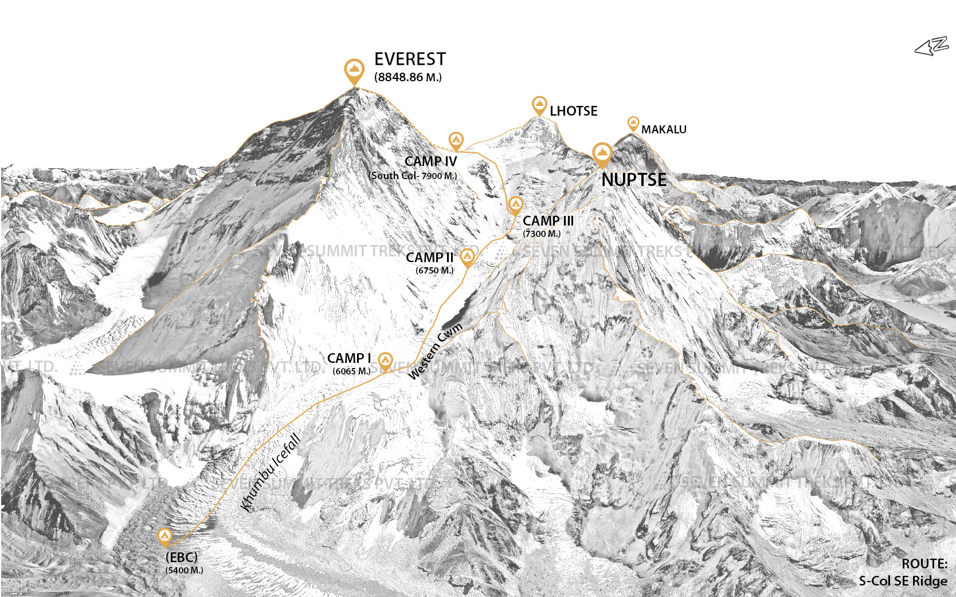

EQUIPMENT LIST: (Equipment shall be arranged by clients themselves, not included in the package cost)

**Travel Documents**

🞏 Valid Passport

🞏 Credit/Debit Card

🞏 PP Size Photo (4 Pieces)

🞏 Insurance Paper And Contact Address

🞏 Family Members / Company’s Contact Address

**Foot Wear**

🞏 Summit Boot - 8000m.

(Kailas / Lasportiva / Millet)

🞏 Climbing Boot - 6000m.

(Kailas / Lasportiva / Millet)

🞏 Normal Socks (5-8 Pairs)

🞏 Summit Socks/6000 m. Socks   
(2 Pairs)

🞏 Trekking Shoes (Gore Tex)

🞏 Light Trekking/Sports Shoes

🞏 Camp Booties (1 Pair)

🞏 Slipper (1 Pair)

**Upper Body**

🞏 Thermal Top Base Layer (2-3 Pcs)

🞏 Fleece Jacket (1-2 Pcs)

🞏 Gore Tex Jacket (1 Pcs)

🞏 Wind Proof Jacket (1-2 Pcs)

🞏 Down Jacket (1-2 Pcs)

🞏 Cotton T-Shirt (3-5 Pcs)

**Lower Body**

🞏 Thermal Bottom Base Layer   
(2-3 Pcs)

🞏 Fleece Trouser (1-2 pcs)

🞏 Gore Tex Pant (1 pcs)

🞏 Mid Weight Pants (1-2 Pcs)

🞏 Light Weight Quick Dry Trekking Pants (2-3 Pairs)

🞏 Gaiters for trekking boots

🞏 Down Pants (1 pcs)

🞏 Under Wear (4-6 Pcs)

**Head**

🞏 Sun Cap

🞏 Desert Cap

🞏 Balaclava

🞏 Fleece Hat/ Warm Hat (1-2 Pcs)

🞏 Neck Gaiter (2-3 Pcs)

**Hands**

🞏 Thin Fleece Gloves (2 Pairs)

🞏 Wind Stopper / Screen Tap Gloves (2 Pairs)

🞏 Heavy Gloves (Guide Gloves)

🞏 Summit Gloves - 8000m.

**Sleeping Bags**

🞏 Sleeping Bag -20OC to -30OC (For Base Camp)

🞏 Down Sleeping Bag -40oC (Extreme Comfort)

🞏 Thermarest Mattress (Cell Foam)

🞏 Down Mattress (Inflatable)

🞏 Sleeping Bag Liner

🞏 Inflatable Pillow

**Climbing Equipment**

🞏 Climbing Helmet

🞏 Summit Down Suit - 8000m.

(Kailas / Marmot / Mountain Hardware / North Face / Millet)

🞏 Crampons (Fit with Boot)/Packing Cover

🞏 Ice Axe with Spike & Axe Protector

🞏 Harness

🞏 Belay Devices/ Figure of 8/ ATC Guide

🞏 Jummer / Ascender

🞏 Lock Carabiner (3 Pcs)

🞏 Unlock Carabiner (2 Pcs)

🞏 Tape Slings/240 cm

🞏 Snow Goggle (Summit Purpose, Antifog, Polarized, UV Ptotection)

🞏 Head Light 500-700 Lumens Spare Battery (Energizer Ultimate Lithium)

🞏 Satellite Phone With Credit (Optional)

🞏 Walking Stick/ Trekking Pole

🞏 Pocket Knife (Swiss)

🞏 Altimeter Watch

🞏 Pee Bottle

🞏 Power Bank

**Bag Packs**

🞏 Rucksacks 35 L - 50 L

🞏 Duffle Bag 120 L-150 L (2 Pcs)

🞏 Water Proof Stuff Sacks/Dry Bag- Small/ Medium/ Large (3-4 Pcs)

**Sun Stuffs**

🞏 Banana Boat/ Nivea Sun Cream (up to -50 Spf)

🞏 Lip Guard -30 to -50 (Spf)

🞏 Sun Glasses (Uv Protection)

🞏 Glaciers Glasses (Uv Protection)

🞏 Moisturiser / Lotion

**Toiletries (Personal)**

🞏 Toilet Paper / Wet Tissue

🞏 Toothpaste & Toothbrush

🞏 Soap

🞏 Shampoo

🞏 Towel

🞏 Garbage Bag

**Eating & Drinking**

🞏 1 Ltr. Water Bottle

🞏 1/ 1.5 Ltr. Thermos

🞏 Mug (Opt.)

🞏 Spoon/ Fork (Opt.)

🞏 Bowl (Opt.)

**Medical/First Aid**

🞏 Brufen/Ibuprofens

🞏 Antibiotic, Paracetamol

🞏 Diamox

🞏 Handy Plaster, Crack Bandage

🞏 Tincture Iodine, Ondem

🞏 Cetirizine, Electrolyte

🞏 Minil 10mg (Palpitation, anxiety)

🞏 Codopar (Headache & chest pain)

🞏 Salbetol 4mg (Breathless)

🞏 Azithromycin 500mg (chronic tonsillitis, fever, nose, throat infection-must take 5 days)

🞏 Flupen 250mg (prevent wound infection)

🞏 Allegra 120/180mg (Allergic tonsil)

🞏 Menstrual Products

**Miscellaneous**

🞏 Nail Cutter

🞏 Umbrella / Rain Coat

🞏 Hot Water Bag

🞏 Tenacious Tape Repair Kits

🞏 Camera

🞏 GPS Tracker (Recommended)

🞏 Hand & Toe Warmer

EXPEDITION COST:

ADD. SERVICES

|  |  |  |
| --- | --- | --- |
| Add + Lobuche peak Climb | **$1000.00** | Consider climbing Lobuche peak (6119 m.) For extra acclimatization |
| Additional Per Sherpa | **$ 9000.00** | We will provide you with One Personal Sherpa during the entire expedition period (1 Member :1 Sherpa), this is included in the program price. However, if you would like to have another extra personal climbing Sherpa (A private 1 Member: 2 Sherpas), you may add to your program. |
| Extra Oxygen Per Bottle | **$ 500.00** | We allocate enough O2 bottles, however, if you want to purchase extra bottles for extra safety. |
| Personal Dining Tent | **$ 2000.00** | To avoid the pandemic scenario or if you are looking for a quiet and silent time at the base camp, you may request a separate dining and resting tent. |
| Add. + Lhotse Climb | **$ 10000.00** | 2 Days extra climbing on Everest Program, to combine the 4th highest peak. Cost covers Sherpa support, high camp logistics, and extra Oxygen bottles. |
| Single Room on Trek | **$ 1000.00** | Single room (Upgraded) during the entire trekking days (both ways). |
| **Helicopter**  - Kathmandu-Lukla  - Basecamp - Lukla  - Basecamp - Kathmandu | **$ 2500.00**  **$ 1800.00**  **$ 4500.00** | A helicopter ride saves your trekking days. If you would like to use the helicopter riding option (Kathmandu to Lukla, Lukla to Basecamp, Basecamp to Lukla or Namche, or direct to Kathmandu) during the expedition period, please let us know a few days earlier. |

INSURANCE:

There is a fine line between adventure and blatant risk. Mountaineering is an adventure trip that carries an intrinsic danger and the nature of travel implies things don’t generally go according to the plan, which is the reason why we require every one of our clients to get acceptable and proper insurance.

Due to unanticipated reasons, for example, injury, family issues, work commitments, etc., clients may need to cancel their trip before the start or during the expedition. Considering these factors, it’s better to be prepared for the possibilities.

As mentioned in the Terms and Conditions of 14mount8000, the agency is exempt from being liable for different expenses that may occur in case of different emergencies or unforeseen situations. In addition to that, a foreigner isn’t allowed to purchase insurance on Nepali soil. Both facts point out the requirement of a client to purchase an elaborate travel insurance plan in their place of origin that protects their interest in case of trip cancellation, helicopter evacuation, medical emergencies, other illnesses, lost luggage, theft, disasters, death, and so on.

You are free to pick your insurer however look for an arrangement that covers trip postponement and cancellation, rescue, and covers medical as well. Guarantee it doesn't have limitations on the height you will climb, prohibitions on the exercises you are embracing, or the places you will be visiting. Protect yourself with the right insurance so you can go on your expedition with peace of mind and focus more on your climbing.

Please make sure to send us a copy of your insurance policy before you start your expedition so that we can assist you in any case of an emergency.

Please find the details about insurance before buying the policy [**here**](https://www.sevensummittreks.com/info/travel-advisory/travel-insurance).

BOOKING & PAYMENT PROCESS:

If you intend to embark on an adventure through 14mount8000. you are required to book a trip 3 months before the trip. A three months preparation period is necessary to ensure maximum safety and satisfaction of the clients.

The client must dispense 30% of the total cost, at the time of booking. The advance amount will be used for the necessary booking of hotels, flights, guides, and porters and receiving approval from governmental authorities. Another 30% of the total charge should be deposited before one month of the flight to Nepal. The remaining 40% of the total charge should be paid after you arrive in Nepal, before the start of your adventure.

After depositing the booking amount to the company's account, we can confirm your registration for our expedition team. You can find all the information about gear lists, itineraries, travel routes, etc. that are required for your expedition on this website that will help you manage everything needed for your expedition.

Once you sign up for the expedition with 14mount8000 - you will have a free consult by our [expert team](https://sevensummittreks.com/our-team.html). We will provide information about personalized strategy, customization, progression planning, expert guiding and coaching, insight, and advice on how to accomplish your adventure goals.

Following the initial application process, you will then:

* Send us your passport copy - during booking.
* Send us a copy of your insurance policy- before your arrival.
* Send us your arrival/departure travel details- before your arrival.
* Send us a copy of your physician’s report (verified by your doctor stating you are fit to join and exercise yourself at a higher altitude) before your arrival.

Please find the details about our payments, cancellation, and refund policies [**here**](https://www.sevensummittreks.com/info/terms-and-conditions/1615622552463669802).

For all expedition enquires and bookings

[**info@14mount8000.com**](mailto:info@14mount8000.com)

FOLLOW US:



[@14moumt8000](https://www.instagram.com/sevensummittreks/)